FEDERAL UNIVERSITY OF TECHNOLOGY MINNA
DEPARTMENT OF COMPUTER SCIENCE

DEVELOPMENT OF AN AUTONOMOUS MAIZE CROP IRRIGATION MONITORING SYSTEM BASED ON SOIL TEXTURE USING MACHINE LEARNING

A Final Year Project Proposal Submitted to the
Department of Computer Science

By
SIMON JOSHUA IFEANYI
Matriculation Number: 2022/2/86304CT

Supervised by:
DR AYOBAMI EKUNDAYO
Signature: _____________________
TABLE OF CONTENT
CHAPTER ONE 4
1.0 INTRODUCTION 4
1.1 Background to the Study 4
1.2 Statement of the Problem 5
1.3 Aim and Objectives of the Study 5
1.4 Significance of the Study 6
1.5 Scope and Limitation of the Study 6
1.6 Organization of the Study 7
CHAPTER TWO 8
2.0 LITERATURE REVIEW 8
2.1 Introduction 8
2.2 Conceptual Review 8
2.2.1 Irrigation and Maize Crop Production 8
2.2.2 Soil Texture and Irrigation Requirement 8
2.2.3 Soil Moisture Monitoring in Smart Irrigation 9
2.2.4 Machine Learning in Irrigation Systems 9
2.2.5 Autonomous Irrigation Monitoring Systems 9
2.3 Related Studies Review 10
2.4 Research Gap 12
CHAPTER THREE 14
3.0 RESEARCH METHODOLOGY AND SYSTEM ANALYSIS DESIGN 14
3.1 Research Methodology 14
3.2 Research Design 14
3.3 System Design and Conceptual Framework 16
3.3.1 Use Case Diagram of the System 18
3.3.2 Sequence Diagram of System Operation 19
3.3.3 Data Flow Diagram of the System 20
3.4 Implementation of the System 21
3.4.1 Algorithm Representation of the System 22
3.5 System Integration and Testing 23
3.6 Summary 23
CHAPTER FOUR 25
4.0 EXPECTED RESULTS AND PRELIMINARY IMPLEMENTATION PLAN 25
REFERENCES 28

CHAPTER ONE

1.0 INTRODUCTION

1.1 Background to the Study
Water availability in soil plays a critical role in crop growth, nutrient absorption, and overall agricultural productivity (Morchid et al., 2024). Proper irrigation management is especially important in maize cultivation because inadequate or excessive watering can negatively affect plant development and yield (Sangeetha & Kumar, 2025). However, irrigation in many small-scale agricultural environments is still carried out manually, which often results in irregular watering schedules and inefficient water use (Singh et al., 2024).
Manual irrigation presents several challenges, including overwatering, underwatering, and dependence on human supervision, all of which may reduce crop performance and increase water wastage (Rahman et al., 2024). In addition, irrigation decisions are often made without adequate consideration of soil conditions. Since soil texture affects water retention, infiltration, and drainage, failure to consider it may result in inappropriate irrigation practices for maize cultivation (Ebstu et al., 2025).
Recent developments in embedded systems, Internet of Things (IoT) technologies, and intelligent control methods have improved the design of smart irrigation systems (Anugrah, 2024). Soil moisture sensors can measure the water content of soil and transmit the readings to a microcontroller such as Arduino for processing (Jha et al., 2020). These systems can also be enhanced through machine learning models that analyze soil moisture and soil texture data in order to support more accurate irrigation decisions (Sangeetha & Kumar, 2025).
Furthermore, web-based monitoring platforms make it possible for users to observe soil conditions and irrigation activities remotely, thereby improving monitoring efficiency and decision-making (Chan et al., 2025). The integration of sensing technology, embedded systems, machine learning, and monitoring interfaces provides a practical approach to intelligent irrigation management for maize production (Karar et al., 2021).
Therefore, this study focuses on the development of an autonomous maize crop irrigation monitoring system based on soil texture using machine learning, with real-time monitoring support through a web-based dashboard.

1.2 Statement of the Problem
Efficient irrigation management remains a major challenge in maize cultivation, particularly in small-scale agricultural environments where watering is often carried out manually. Traditional irrigation practices rely heavily on human observation and judgment, which may lead to irregular watering schedules, inefficient water use, and poor crop performance (Singh et al., 2024). Such practices may result in either over-irrigation or under-irrigation, both of which can negatively affect maize growth and soil condition (Sangeetha & Kumar, 2025).
Another major problem is that irrigation decisions are often made without adequate knowledge of soil moisture status and soil texture characteristics. Soil texture influences the rate at which water is retained or lost in the soil, and failure to consider this factor may reduce the effectiveness of irrigation scheduling (Rahman et al., 2024). Without proper monitoring and analysis of these conditions, farmers may apply water at the wrong time or in the wrong quantity, leading to water wastage and reduced productivity (Ebstu et al., 2025).
In addition, many existing irrigation systems depend on constant human supervision and do not provide intelligent decision support for crop-specific irrigation management (Anugrah, 2024). This creates the need for a system that can monitor soil moisture conditions, incorporate soil texture information, and automatically determine when irrigation should be activated for maize cultivation.
Consequently, there is a need for an autonomous irrigation monitoring system that integrates soil moisture sensing, soil texture consideration, machine learning-based decision-making, and automated irrigation control in order to improve irrigation efficiency and support sustainable maize production (Morchid et al., 2024).

1.3 Aim and Objectives of the Study
The aim of this project is to develop an autonomous maize crop irrigation monitoring system based on soil texture using machine learning. To actualize this aim, the following objectives are outlined:
- To design an autonomous maize crop irrigation monitoring system based on soil texture using machine learning;
- To implement the design of the autonomous maize crop irrigation monitoring system based on soil texture using machine learning;
- To evaluate the implementation of the autonomous maize crop irrigation monitoring system based on soil texture using machine learning.

1.4 Significance of the Study
This project contributes to the advancement of intelligent irrigation technologies aimed at improving water management and maize crop productivity. By integrating soil moisture sensing, soil texture analysis, and a machine learning-based decision model, the proposed system supports more accurate and efficient irrigation scheduling compared to traditional manual irrigation practices (Sangeetha & Kumar, 2025). The system is expected to reduce unnecessary water usage while maintaining optimal soil moisture conditions required for maize growth (Morchid et al., 2024). In addition, the incorporation of a web-based monitoring dashboard enables users to observe soil moisture levels and irrigation activities in real time, thereby improving monitoring efficiency and decision-making (Chan et al., 2025). Overall, the study demonstrates the practical application of embedded systems, sensor technologies, and machine learning techniques in addressing agricultural irrigation challenges and contributes to the advancement of smart agriculture technologies (Karar et al., 2021).

1.5 Scope and Limitation of the Study
This project focuses on the design and implementation of an Autonomous Maize Crop irrigation monitoring system based on soil texture using machine learning, which also includes a web-based dashboard for monitoring soil moisture levels and irrigation activity. However, the study is limited to the development of a small-scale automated irrigation system suitable for home gardens or small agricultural plots (Singh et al., 2024), and the system utilizes a single soil moisture sensor, which may not accurately represent moisture variations across large agricultural fields (Ebstu et al., 2025). Additionally, the system focuses primarily on soil moisture monitoring and automated irrigation control and does not incorporate other environmental parameters such as temperature, humidity, or weather prediction models that may influence irrigation requirements (Karar et al., 2021).

1.6 Organization of the Study
This project is organised into five chapters. Chapter One presents the introduction of the study, covering the background to the study, statement of the problem, aim and objectives, significance of the study, and scope and limitation of the study.
Chapter Two presents the literature review, covering the conceptual review, related studies, and the research gap relevant to autonomous maize irrigation monitoring systems based on soil texture and machine learning.
Chapter Three presents the research methodology, including the research design, design of the conceptual framework, implementation of the proposed system, and evaluation of the system performance.
Chapter Four presents the expected results and preliminary implementation plan, outlining the anticipated outcomes of the study and the schedule for the development, testing, and documentation of the proposed system.
Chapter Five presents the conclusion and recommendations of the study, summarising the major findings, evaluating the achievement of the study objectives, and providing recommendations for future improvement of the proposed system.

CHAPTER TWO

2.0 LITERATURE REVIEW

2.1 Introduction
This chapter reviews the concepts, technologies, and previous studies relevant to the development of an autonomous maize crop irrigation monitoring system based on soil texture using machine learning. The review focuses on soil texture and soil moisture relationship, maize water requirement, smart irrigation systems, soil moisture sensing technologies, and the application of machine learning in irrigation decision-making. It also presents related studies in tabular form and identifies the research gap that justifies the proposed study.

2.2 Conceptual Review

2.2.1 Irrigation and Maize Crop Production
Maize is one of the most widely cultivated cereal crops in the world and serves as a major source of food, livestock feed, and industrial raw materials (Morchid et al., 2024). The productivity of maize depends significantly on proper water management, particularly during critical growth stages such as germination, tasseling, and grain filling (Singh et al., 2024). Insufficient irrigation may reduce crop growth, leaf development, and grain yield, while excessive irrigation may lead to water wastage, nutrient leaching, and poor soil aeration (Sangeetha & Kumar, 2025). For this reason, effective irrigation scheduling is essential for maintaining optimal soil moisture conditions for maize cultivation.

2.2.2 Soil Texture and Irrigation Requirement
Soil texture refers to the proportion of sand, silt, and clay particles present in soil and plays a critical role in determining soil water retention and infiltration properties (Rahman et al., 2024). Sandy soils typically allow water to drain quickly and therefore require more frequent irrigation, whereas clay soils retain water for longer periods but may reduce drainage efficiency (Pitoro et al., 2025). Loamy soils, which contain balanced proportions of sand, silt, and clay, generally provide favorable conditions for plant growth because they maintain adequate moisture while allowing proper drainage (Nagalingam et al., 2024). Because soil texture directly affects soil moisture dynamics and crop water availability, irrigation systems should consider soil texture characteristics when determining irrigation schedules.

2.2.3 Soil Moisture Monitoring in Smart Irrigation
Soil moisture monitoring has become a key component of modern irrigation management systems. Soil moisture sensors are commonly used to measure the amount of water present in the soil and to assist in determining appropriate irrigation timing (Ebstu et al., 2025). In automated irrigation systems, sensor readings are transmitted to a processing unit, usually a microcontroller, which analyzes the data and determines whether irrigation should be activated (Jha et al., 2020). Continuous monitoring of soil moisture conditions helps reduce both over-irrigation and under-irrigation while improving water use efficiency (El Mezouari et al., 2022).

2.2.4 Machine Learning in Irrigation Systems
Machine learning techniques have recently gained attention in precision agriculture because they enable irrigation decisions to be made using data-driven approaches rather than fixed rules (Sangeetha & Kumar, 2025). Machine learning models can analyze large amounts of agricultural data, including soil moisture levels, soil texture, crop type, and environmental variables, in order to predict irrigation requirements more accurately (Morchid et al., 2024). Compared to traditional threshold-based irrigation systems, machine learning-based approaches can adapt to changing environmental conditions and improve irrigation decision accuracy over time (Rahman et al., 2024).

2.2.5 Autonomous Irrigation Monitoring Systems
Autonomous irrigation systems integrate sensing technologies, microcontroller processing units, and automated irrigation mechanisms to reduce the need for constant human supervision (Anugrah, 2024). Such systems are capable of detecting soil conditions, making irrigation decisions, and activating irrigation devices automatically when required (Kumar et al., 2020). In many modern systems, monitoring dashboards or web-based interfaces are included to allow users to observe soil moisture levels and irrigation activities remotely (Chan et al., 2025). These technologies contribute to improved irrigation efficiency, water conservation, and better crop management practices.

2.3 Related Studies Review
Several researchers have developed automated irrigation systems using soil moisture sensors, microcontrollers, Internet of Things (IoT) technologies, and predictive algorithms. These studies demonstrate the growing importance of smart irrigation systems in improving agricultural productivity and water management (Morchid et al., 2024). However, most existing studies focus primarily on irrigation automation or monitoring systems without fully integrating soil texture analysis and machine learning techniques for maize irrigation management.
For instance, Anugrah (2024) developed an Arduino-based automatic watering system that uses soil moisture sensors to control irrigation automatically. Similarly, Jha et al. (2020) designed a soil moisture-based automatic irrigation system capable of activating irrigation when soil moisture levels fall below a predefined threshold. These studies demonstrate the effectiveness of microcontroller-based irrigation control systems.
Other studies have explored IoT-based irrigation monitoring systems. Morchid et al. (2024) proposed a smart irrigation management system that integrates IoT technologies to monitor soil moisture conditions and improve water management in agricultural fields. Rahman et al. (2024) also developed an IoT-based soil monitoring system capable of collecting soil data remotely for agricultural decision-making.
In addition, several researchers have focused on improving soil moisture sensing technologies for irrigation applications. For example, Ebstu et al. (2025) developed and tested a low-cost soil moisture sensor that can be used for irrigation scheduling, while Pitoro et al. (2025) demonstrated the effectiveness of capacitive soil moisture sensors for monitoring soil moisture conditions.
More advanced irrigation approaches have also been proposed using predictive models and artificial intelligence techniques. Sangeetha and Kumar (2025) developed a smart irrigation system that applies predictive algorithms to determine irrigation schedules based on soil conditions and environmental factors. However, such systems often require complex computational models and large datasets for effective implementation.
Table 1 presents a summary of selected related studies relevant to this research.
Table 1: Summary of Related Studies
S/N | Author(s) | Year | System / Method | Key Findings | Identified Gap
1 | Anugrah | 2024 | Arduino-based automatic watering system | Developed automatic irrigation using soil moisture sensors and Arduino. | Did not incorporate soil texture analysis or machine learning.
2 | Arafa et al. | 2024 | Soil moisture sensor deployment optimization | Improved irrigation efficiency through optimized sensor placement. | Focused on sensor deployment rather than autonomous irrigation prediction.
3 | Ebstu et al. | 2025 | Low-cost soil moisture sensing technology | Developed and tested a low-cost soil moisture sensor for irrigation scheduling. | Did not integrate irrigation automation with predictive intelligence.
4 | El Mezouari et al. | 2022 | Sensor-based smart irrigation control | Demonstrated improved irrigation efficiency using sensor monitoring. | Did not incorporate crop-specific irrigation modeling.
5 | Morchid et al. | 2024 | IoT-based irrigation management system | Demonstrated improved water management using IoT technologies. | Focused mainly on large-scale irrigation systems.
6 | Nagalingam et al. | 2024 | Soil moisture monitoring irrigation system | Developed automated irrigation monitoring for agricultural fields. | Did not integrate machine learning or soil texture analysis.
7 | Pitoro et al. | 2025 | Capacitive soil moisture sensing irrigation system | Demonstrated reliable soil moisture measurement for irrigation. | Focused mainly on sensor performance.
8 | Rahman et al. | 2024 | IoT-based soil characterization system | Developed remote soil monitoring system for agriculture. | Focused more on monitoring than irrigation automation.
9 | Sangeetha & Kumar | 2025 | Predictive irrigation system using IoT | Applied predictive algorithms for irrigation scheduling. | Did not specifically focus on maize crop irrigation.
10 | Suleiman et al. | 2025 | Intelligent IoT-based irrigation system | Integrated Arduino and IoT technologies for irrigation automation. | System complexity may limit small-scale applications.

2.4 Research Gap
The reviewed literature shows that many automated irrigation systems have been developed using soil moisture sensors, microcontrollers, and IoT technologies to improve irrigation efficiency and water management (Morchid et al., 2024; Suleiman et al., 2025). However, several limitations remain in existing studies.
First, many irrigation systems rely on simple threshold-based irrigation control without incorporating machine learning techniques that can improve irrigation decision accuracy (Sangeetha & Kumar, 2025). Second, several studies focus mainly on soil moisture monitoring without considering soil texture as an important factor influencing water retention and irrigation requirements (Rahman et al., 2024). Third, many existing systems are designed for general irrigation applications rather than focusing on specific crops such as maize, which has distinct water requirements during different growth stages (Singh et al., 2024).
Therefore, there is a need for an irrigation system that integrates soil moisture monitoring, soil texture consideration, and machine learning techniques to improve irrigation decision-making for maize cultivation. This study addresses this gap by developing an autonomous maize crop irrigation monitoring system that uses soil texture and soil moisture data within a machine learning framework to support intelligent irrigation control.

CHAPTER THREE

3.0 RESEARCH METHODOLOGY AND SYSTEM ANALYSIS DESIGN

3.1 Research Methodology
This chapter describes the methodology adopted for the development of the autonomous maize crop irrigation monitoring system based on soil texture using machine learning. The chapter presents the research design, the conceptual framework design of the proposed system, the implementation approach, and the evaluation procedure used to assess the system performance. The methodology is structured around the objectives of the study to ensure that each objective is systematically achieved.

3.2 Research Design
The research design describes the structured approach used to achieve the objectives of the study. The design follows a systematic process involving the design of a conceptual framework, the implementation of the proposed irrigation monitoring system, and the evaluation of the developed system. Similar design and implementation approaches have been widely used in smart irrigation system development and agricultural monitoring studies (El Mezouari et al., 2022; Suleiman et al., 2025).
In this study, the irrigation decision process is supported by a Decision Tree machine learning model, which analyzes soil moisture and soil texture information to determine appropriate irrigation actions. The activities required to achieve the objectives of the study are summarized in Table 2.
Table 2: Research Design Framework
Objectives | Steps | Methods
To design an autonomous maize crop irrigation monitoring system based on soil texture using machine learning | Study existing irrigation monitoring frameworks and smart agriculture systems | Literature review
 | Identify gaps and limitations in existing irrigation monitoring systems | Literature review
 | Develop a conceptual framework for the proposed irrigation monitoring system | System modeling using Microsoft Visio
To implement the design of an autonomous maize crop irrigation monitoring system based on soil texture using machine learning | Develop system architecture integrating sensing, processing, and irrigation control components | System design
 | Develop the control algorithm for irrigation decision-making | Arduino programming and machine learning techniques
 | Integrate sensors, microcontroller, irrigation pump, and monitoring interface | Hardware and software integration
To evaluate the implementation of the autonomous maize crop irrigation monitoring system | Test the developed system under different soil moisture conditions | Experimental testing
 | Analyze system performance and irrigation response accuracy | Data analysis

Explanation of Table 2
Table 2 presents the research design adopted for the development of the proposed autonomous maize irrigation monitoring system. The table outlines the objectives of the study, the steps required to achieve each objective, and the methods used to carry out those steps.
The first objective focuses on the design of the conceptual framework for the irrigation monitoring system. This involves reviewing existing irrigation monitoring frameworks through literature review and identifying the limitations of current systems. Based on the identified gaps, a conceptual framework for the proposed system is developed using system modeling tools such as Microsoft Visio.
The second objective focuses on implementing the proposed irrigation monitoring system. This involves designing the system architecture, developing the irrigation control algorithm, and integrating the sensing components, processing unit, irrigation mechanism, and monitoring interface.
The third objective focuses on evaluating the performance of the developed system. This involves testing the system under different soil moisture conditions and analyzing the system’s ability to correctly detect soil dryness and activate irrigation when required.

3.3 System Design and Conceptual Framework
The system design represents the logical and functional architecture through which the proposed autonomous maize irrigation monitoring system operates. Unlike conventional irrigation systems that rely on static thresholds, this study adopts a data-driven and context-aware design that integrates soil moisture sensing with soil texture characterization and machine learning-based decision-making.
The conceptual framework is developed to establish the interaction between environmental inputs, computational processes, and irrigation outputs. In precision agriculture, such frameworks are essential for modeling system intelligence and ensuring that irrigation decisions reflect actual soil conditions rather than generalized assumptions (Morchid et al., 2024).
The system is structured around four interconnected layers: data acquisition, processing and decision-making, actuation, and monitoring. The data acquisition layer captures real-time soil moisture values using a soil moisture sensor, while soil texture information is introduced as a static but critical parameter influencing water retention behavior. Soil texture plays a significant role in determining irrigation frequency and water availability, as sandy soils drain quickly while clay soils retain water for longer durations (Rahman et al., 2024).
The processing layer is implemented using an Arduino microcontroller, which serves as the central control unit. The microcontroller integrates sensor readings with soil texture classification and applies a Decision Tree machine learning model to evaluate irrigation requirements. Decision Tree models are particularly suitable for embedded agricultural systems due to their low computational complexity and interpretability (Sangeetha & Kumar, 2025). Unlike black-box models, the Decision Tree provides explicit rules that can be embedded directly into microcontroller logic, thereby enhancing system transparency and efficiency.
The actuation layer consists of a relay-controlled water pump that is activated when the system detects inadequate soil moisture relative to soil texture conditions. This ensures that irrigation decisions are not only reactive but also context-sensitive. The monitoring layer includes a web-based interface that provides real-time feedback on soil moisture levels and irrigation status, thereby improving system observability and user interaction (Karar et al., 2021).
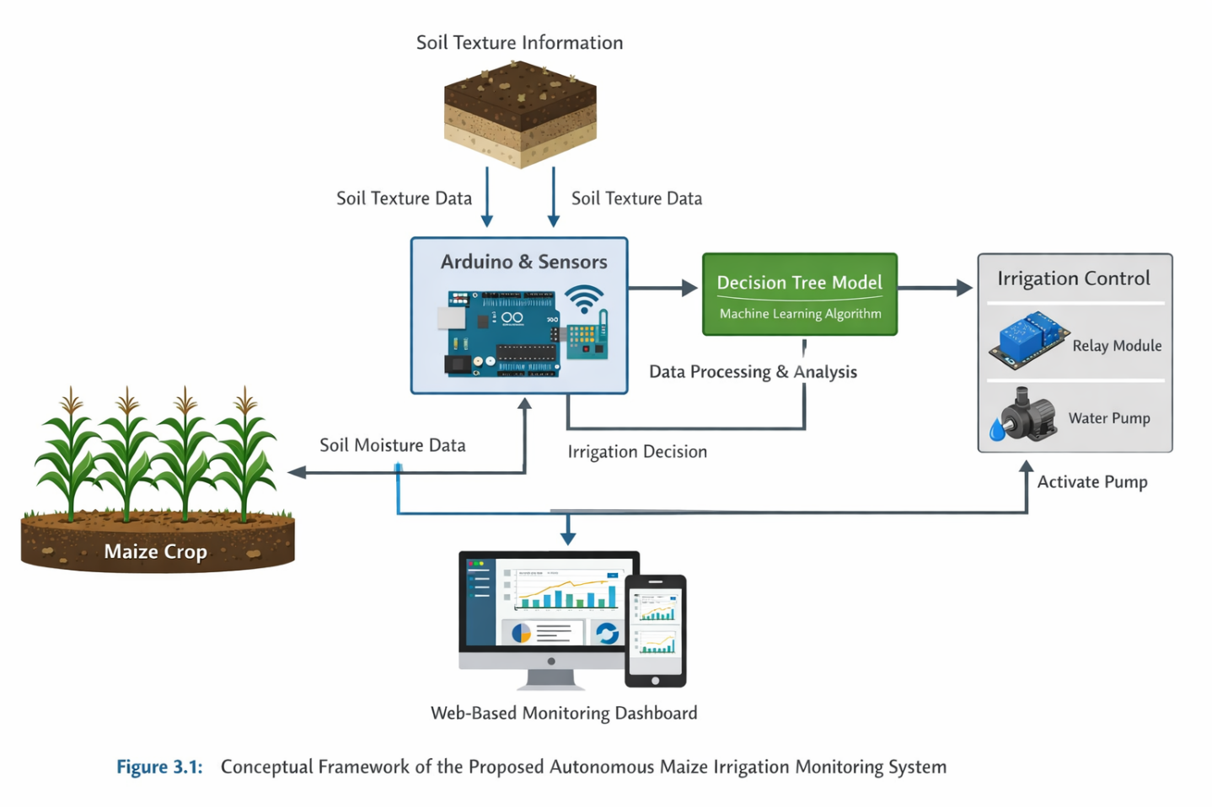
Figure 3.1: Conceptual Framework of the Autonomous Maize Irrigation Monitoring System
As illustrated in Figure 3.1, the proposed system operates as a closed-loop intelligent irrigation system in which environmental data is continuously sensed, processed, and translated into irrigation actions. This closed-loop design is critical in minimizing water wastage and ensuring that irrigation is applied only when necessary.

3.3.1 Use Case Diagram of the System
The use case diagram provides a functional representation of how users interact with the irrigation monitoring system and how the system performs its core operations autonomously. Unlike purely technical diagrams, use case diagrams focus on system usability and operational scope.
In this system, the primary actor is the user (farmer or system operator), whose role is largely supervisory rather than operational. This reflects a shift from manual irrigation practices to automated and intelligent irrigation systems. The user interacts with the system mainly through monitoring functions, while irrigation decisions are executed autonomously by the system.
This design approach aligns with modern smart agriculture systems, where human intervention is minimized and decision-making is delegated to intelligent control systems (Suleiman et al., 2025).
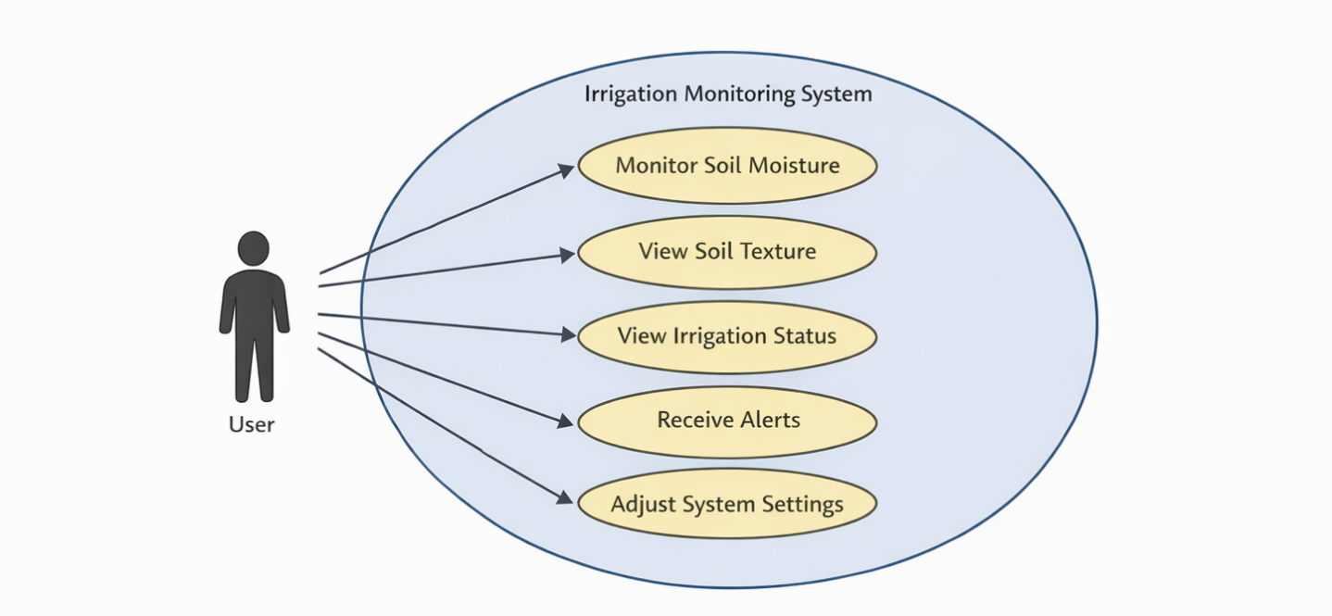
Figure 3.2: Use Case Diagram of the Irrigation Monitoring System
Figure 3.2 illustrates that the system automates core processes such as soil monitoring, decision-making, and irrigation control, while the user is primarily responsible for observing system performance and making adjustments when necessary.

3.3.2 Sequence Diagram of System Operation
The sequence diagram presents a time-ordered representation of interactions between system components during irrigation decision-making. This diagram is critical for understanding the dynamic behavior of the system and the flow of control signals.
The irrigation process begins with soil moisture sensing, followed by data transmission to the Arduino microcontroller. The microcontroller then integrates soil texture data and processes the combined input using the Decision Tree model. Based on the classification result, a control signal is sent to the relay module, which activates or deactivates the water pump.
Sequence modeling is particularly important in embedded systems, as it ensures that timing dependencies and communication sequences are correctly implemented (El Mezouari et al., 2022).
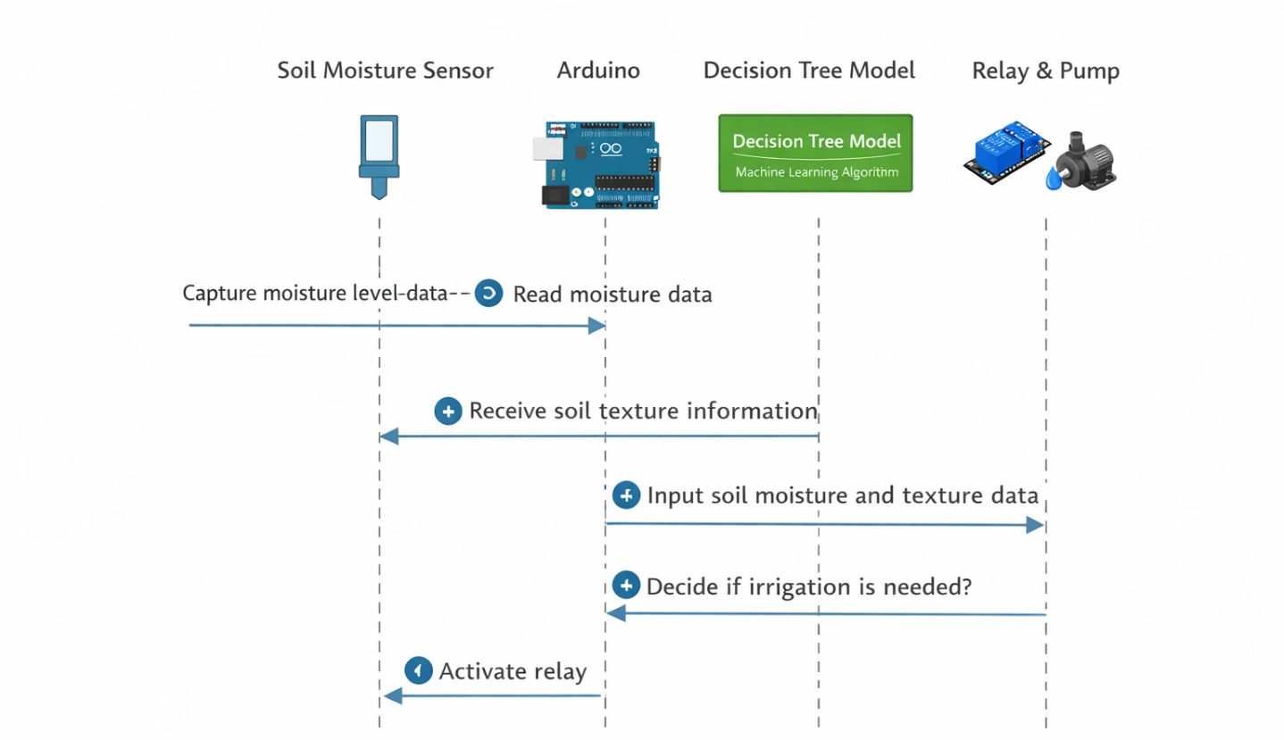
Figure 3.3: Sequence Diagram of Irrigation Decision Process
As shown in Figure 3.3, the system follows a deterministic sequence of sensing, processing, decision-making, and actuation. This structured flow reduces ambiguity and ensures consistent system behavior.

3.3.3 Data Flow Diagram of the System
The data flow diagram (DFD) provides a detailed representation of how data is processed within the irrigation monitoring system. Unlike the conceptual framework, which focuses on system structure, the DFD emphasizes data transformation and movement.
In the proposed system, soil moisture data is captured by the sensor and transmitted to the processing unit. The processing unit combines this data with soil texture information and applies the Decision Tree model to generate irrigation decisions. The output is then transmitted to both the actuation unit and the monitoring interface.
Data flow modeling is essential in system design as it helps identify potential inefficiencies and ensures that data is processed accurately and efficiently (Rahman et al., 2024).
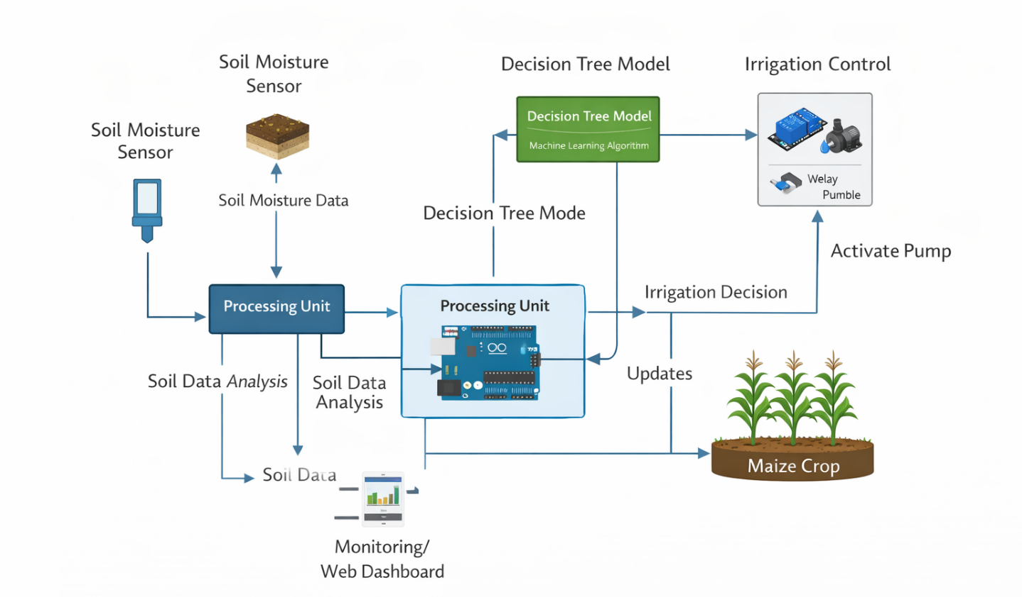
Figure 3.4: Data Flow Diagram of the Irrigation Monitoring System
Figure 3.4 demonstrates that the system maintains a continuous flow of data from sensing to decision-making and output generation, ensuring real-time responsiveness.

3.4 Implementation of the System
The implementation phase translates the conceptual design into a functional system by integrating hardware and software components. This phase is critical because it determines the practical feasibility of the proposed irrigation monitoring system.
Hardware Implementation
The hardware architecture consists of a soil moisture sensor, Arduino microcontroller, relay module, water pump, and power supply unit. These components are interconnected to form a complete irrigation control system.
Soil moisture sensors are widely used in agricultural systems due to their ability to provide real-time measurements of soil water content (Ebstu et al., 2025). The Arduino microcontroller processes these measurements and executes control logic, while the relay module acts as an interface between the low-power microcontroller and the high-power water pump.
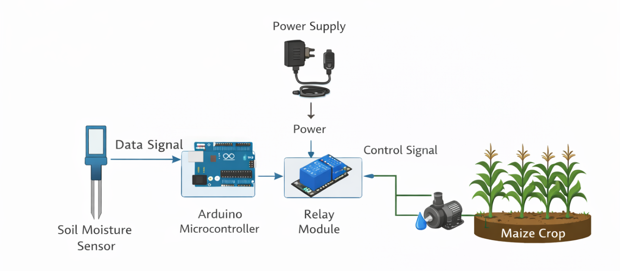
Figure 3.5: Hardware Architecture of the Irrigation Monitoring System
As illustrated in Figure 3.5, the hardware components are arranged in a modular structure that supports scalability and ease of maintenance.
Software Implementation
The software component is implemented using the Arduino Integrated Development Environment (IDE) with embedded C/C++ programming. The control algorithm reads sensor data, incorporates soil texture information, and applies Decision Tree logic to determine irrigation actions.
The use of machine learning enhances system adaptability by enabling the system to respond to varying soil conditions rather than relying on fixed thresholds (Sangeetha & Kumar, 2025).

3.4.1 Algorithm Representation of the System
The algorithm representation provides a logical description of the irrigation decision process. It ensures that the system operates in a consistent and predictable manner.
Table 3.2: Algorithm Representation of the Irrigation System
Step | Description
1 | Initialize system
2 | Read soil moisture value
3 | Identify soil texture
4 | Input data into Decision Tree model
5 | Evaluate irrigation condition
6 | If moisture is below required level → Activate irrigation
7 | Else → Maintain current state
8 | Update monitoring system
9 | Repeat continuously

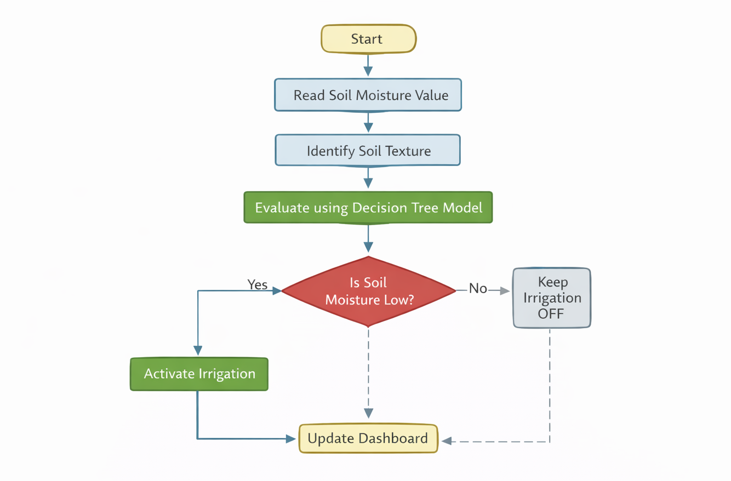
Figure 3.6: Algorithm Flowchart of Irrigation Decision Process
Figure 3.6 illustrates the logical flow of irrigation decision-making, highlighting the integration of sensor input, machine learning evaluation, and control output.

3.5 System Integration and Testing
System integration ensures that all hardware and software components function cohesively. This phase is essential for validating system reliability and operational accuracy.
Testing is conducted under varying soil moisture conditions to evaluate system performance. Experimental testing is widely used in irrigation system development to assess accuracy and responsiveness (El Mezouari et al., 2022).

3.6 Summary
This section has presented the system design, conceptual framework, and implementation methodology of the proposed irrigation monitoring system. The integration of sensing technologies, machine learning, and automated control provides a robust solution for improving irrigation efficiency and supporting sustainable maize production (Morchid et al., 2024).

CHAPTER FOUR

4.0 EXPECTED RESULTS AND PRELIMINARY IMPLEMENTATION PLAN
The expected results of this study focus on the successful development and demonstration of an autonomous maize crop irrigation monitoring system based on soil texture using machine learning.
The first expected outcome of this study is the development of a soil moisture sensing mechanism capable of accurately detecting soil moisture conditions. The soil moisture sensor is expected to continuously measure soil moisture levels and transmit the readings to the microcontroller for processing and analysis.
The second expected outcome is the successful implementation of a machine learning-based irrigation decision model using the Decision Tree algorithm. The model will analyze soil moisture levels and soil texture characteristics in order to determine whether irrigation should be activated. This approach is expected to improve irrigation decision accuracy compared to simple threshold-based systems.
The third expected outcome is the implementation of an automated irrigation control system that activates irrigation when the Decision Tree model predicts that irrigation is required. This mechanism is expected to maintain appropriate soil moisture levels for maize cultivation while minimizing unnecessary water usage.
The fourth expected outcome is the development of a web-based monitoring dashboard that displays soil moisture levels and irrigation system status in real time. This interface will allow users to monitor irrigation activities remotely and observe the performance of the irrigation monitoring system.
The final expected outcome is the successful demonstration of an intelligent irrigation system capable of improving irrigation efficiency, reducing water wastage, and minimizing the need for manual plant watering.
Table 3 Preliminary Implementation Plan
Stage | Activity | Expected Output | Timeline
Project Planning | Review of literature, refinement of research design, and finalization of system requirements | Clearly defined system architecture and project roadmap | Week 1
Component Acquisition | Procurement of hardware components including Arduino microcontroller, soil moisture sensor, relay module, water pump, and other required materials | Availability of all hardware components required for system development | Week 2
Hardware Development | Assembly and connection of the soil moisture sensor, Arduino microcontroller, relay module, and water pump | Functional hardware prototype of the automated irrigation system | Week 3 – 4
Software Development | Development of Arduino control program and implementation of the Decision Tree irrigation decision model | Working irrigation control algorithm implemented in the microcontroller | Week 5 – 7
Dashboard Development | Design and implementation of the web-based monitoring dashboard | Functional interface displaying soil moisture level and irrigation status | Week 8 – 9
System Integration | Integration of hardware components with the control program and monitoring dashboard | Fully integrated automated irrigation system | Week 10
System Testing | Testing the system under different soil moisture conditions to verify proper irrigation activation | Test data on soil moisture detection and irrigation performance | Week 11
Evaluation and Documentation | Analysis of system performance, evaluation of results, and preparation of project documentation | Final system evaluation results and completed project report | Week 12

REFERENCES
Akter, S., Rahman, M., & Islam, M. (2025). Development of smart micro-irrigation system using Arduino Uno for okra cultivation. Research in Agricultural Engineering. https://www.agriculturejournals.cz/artkey/rae-202501-0004_development-of-smart-micro-irrigation-system-using-arduino-uno-for-okra-cultivation-in-bangladesh.php⁠
Anugrah, R. A. (2024). An automatic watering system based on an Arduino microcontroller for precision irrigation. BIO Web of Conferences, 63, 02003. https://www.bio-conferences.org/articles/bioconf/abs/2024/63/bioconf_sage-grace2024_02003/bioconf_sage-grace2024_02003.html
Arafa, Y., Abdalla, M., & Hussein, M. (2024). Improving the spatial deployment of soil moisture sensors using geographic information system techniques. Cogent Engineering, 11(1). https://doi.org/10.1080/23311932.2024.2361124
Aslinda, N., Rahman, M., & Hasan, M. (2019). An automated irrigation system using Arduino microcontroller. International Journal of Engineering Research and Technology. https://www.researchgate.net/publication/330212779_An_Automated_Irrigation_System_Using_Arduino_Microcontroller
Cadao, J. M. G., Jumawid, J. L., Lofranco, J. K. C., Polestico, N., Ibale, R., & Perin, M. A. (2024). Automated plant watering system using Arduino. ResearchGate. https://www.researchgate.net/publication/353164327_AUTOMATED_PLANT_WATERING_SYSTEM_USING_ARDUINO
Casado, C. G., Cisquella, M. L., & López, S. A. (2018). Intelligent irrigation system based on Arduino. arXiv. https://arxiv.org/abs/1803.00097
Chan, C. K., Wong, K. L., & Tan, J. S. (2025). A solar-powered automated irrigation system using Arduino and soil moisture sensors. Engineering, Technology & Applied Science Research, 15(1), 13798–13805. https://doi.org/10.48084/etasr.11206
Dapitilla, M. A., Cadao, J. M., & Jumawid, J. L. (2021). Developing a smart irrigation system using Arduino. ResearchGate. https://www.researchgate.net/publication/352798481_Developing_a_Smart_Irrigation_System_Using_Arduino
Ebstu, E. T., Mekonnen, B., & Tesfaye, A. (2025). Development and testing of a low-cost soil moisture sensor for irrigation scheduling. Irrigation and Drainage. https://doi.org/10.1002/ird.70026
El Mezouari, A., Belkadi, B., & Bouchentouf, T. (2022). Smart irrigation system based on sensor monitoring and automated control. IFAC-PapersOnLine, 55(10), 161–166. https://doi.org/10.1016/j.ifacol.2022.09.365
Jha, S. K., Shrestha, S., & Adhikari, R. (2020). Design and development of soil moisture based automatic irrigation system using Arduino. Journal La Multiapp. https://newinera.com/index.php/JournalLaMultiapp/article/view/197
Karar, M. E., Alotaibi, F., Al Rasheed, A., & Reyad, O. (2021). A pilot study of smart agricultural irrigation using IoT-based cloud systems. arXiv. https://arxiv.org/abs/2101.01851
Kumar, V., Singh, P., & Sharma, A. (2020). Arduino-based automatic soil moisture monitoring and irrigation control system. International Journal of Progressive Research in Science and Engineering. https://journal.ijprse.com/index.php/ijprse/article/view/121
Morchid, A., El Alami, J., & Lakhouaja, A. (2024). IoT-based smart irrigation management system for sustainable agriculture. Smart Agricultural Technology, 7, 100446. https://doi.org/10.1016/j.atech.2024.100446
Nagalingam, R., Rajkumar, P., & Kumar, V. (2024). Automatic monitoring of soil moisture and irrigation control for farming land. Agriculture Journal. https://www.agriculturejournal.org/volume11number3/smart-agriculture-automatic-monitoring-of-soil-moisture-and-irrigation-control-for-farming-land/
Pitoro, V. S. J., Ncube, B., & Moyo, T. (2025). Application of low-cost capacitive soil moisture sensors for irrigation management using Arduino microcontrollers. Smart Agricultural Technology. https://www.sciencedirect.com/science/article/pii/S2772375525008275
Rahman, M. N., Sozol, S. S., Islam, M. T., & Hossin, M. S. (2024). Soil characterization of agricultural fields through Internet of Things based monitoring systems. arXiv. https://arxiv.org/abs/2411.17731
Sangeetha, S. K. B., & Kumar, R. (2025). Smart irrigation system using soil moisture prediction with IoT. Artificial Intelligence in Agriculture. https://ojs.bonviewpress.com/index.php/AIA/article/view/1514
Singh, P., Patel, D., & Sharma, N. (2024). Smart irrigation system using Arduino to monitor environmental parameters. International Journal of Research in Engineering and Science. https://www.ijres.org/papers/Volume-12/Issue-10/12106674.pdf
Suleiman, A., Ibrahim, H., & Musa, A. (2025). Design and implementation of an intelligent IoT-based irrigation system using Arduino and soil moisture sensors. World Journal of Advanced Engineering Technology and Sciences. https://wjaets.com/sites/default/files/fulltext_pdf/WJAETS-2025-0113.pdf

